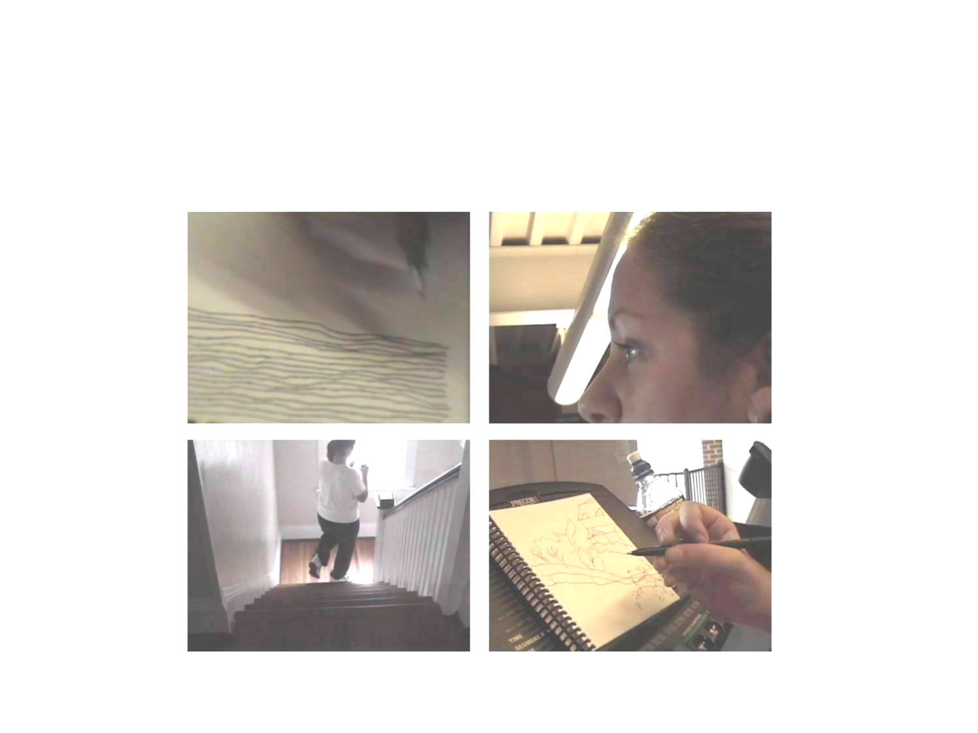
Kristin Beal-DeGrandmont

405 Westover Boulevard
Lynchburg, Virginia 24501
(434) 846-6864 (hm)
(434) 544-8714 (office)
(804) 519-4472 (cell) (CAA)
beal_k@lynchburg.edu

The Multi-tasking Series. Drawing Exercises.

Education
2002 MFA, Virginia Commonwealth University
1999 BFA, Wichita State University
1990 Kansas City Art Institute

Areas of Specialization: Drawing, Painting, and Installation Art.

Teaching Experience

Expertise: Perceptual Drawing/Painting, Installation and Conceptualization.

2004-05 Instructor of Art, Lynchburg College, Lynchburg, Virginia
Courses taught:
Art 110: Introduction to Visual Art (3 sections)
Art 156: Drawing I (2 sections)
Art 480: Special Problems: Installation (Independent study)
Instructor of Art (Spring), Randolph Macon Women’s College, Lynchburg, Virginia
Courses taught:
Art 103: Introduction to Studio Art
Art 233: Oil Painting
2003-04 Instructor of Art, Lynchburg College, Lynchburg, Virginia
Courses taught:
Art 110: Introduction to Visual art (2 sections)
Art 156: Drawing I (2 sections)
Art 256: Drawing II
Art 262: Painting II
Art 362: Advanced Painting
Art 480: Special Problems: Drawing (Independent study)
2002-03 Adjunct faculty, Longwood University, Farmville, Virginia
Courses taught:
Art 130: Drawing I (3 sections)
Art 131: Life drawing 1 (2 sections)
Adjunct faculty, J. Sargeant Reynolds Community College, Richmond, Virginia
Courses taught:

Art 121: Drawing I
Art 125: Introduction to painting (2 sections)
2001 Adjunct faculty, Virginia Commonwealth University, Richmond, Virginia
Courses taught:

Art 205: Painting I
2000 Graduate Fellowship, Virginia Commonwealth University, Richmond, Virginia
Courses taught:
Art 205: Drawing I (Instructor of record)

Extracurricular Teaching Activities
Faculty Advisor, Graphic Arts Club
Faculty Advisor, Student Art Forum
Member, Senior Seminar Committee
Member, Sommerville Scholarship Committee

Organized monoprinting workshop with visiting artist James Diffin.

Implemented eight-week collaboration between fifty students and visiting artist Lisa Fletcher. Ms.
Fletcher spent one week with students installing an outdoor, site-specific installation based on the
students’ linear interpretation of systems. Prior to Ms. Fletcher’s arrival project participants researched
a variety of systems, prepared diagrammatical drawings and maintained communication with the artist
in order to select and prepare the final systems to be represented, including: river systems, the Internet,
flight patterns, and the circulatory system.

Organized gallery lecture for Art Department with Alexi Chisler in conjunction with her exhibition
Along Line on view at Riverviews Artspace, Lynchburg, Virginia.

Student Achievements
Students Holly Rozanski and Phillip Robb chosen to exhibit video works at Don Bosco College
in Kathmandu, Nepal.

Jamesha Hairston chosen to exhibit artwork at The Art Box, Lynchburg, VA.

Grace Rochfort chosen to participate in the traveling exhibition Baja to Vancouver made possible
by learningtoloveyoumore.com. Venues include: San Diego Museum of Contemporary Art,
San Diego, CA; Seattle Art Museum, Seattle, WA; CCA Wattis Institute for Contemporary
Arts, San Francisco, CA.

Professional Activities
2002-03 Board Member, Orange Door Gallery, Richmond, Virginia
2002-04 Board Member, 1708 Gallery, Richmond, Virginia
Vice Chair: Exhibitions Committee.
Co-curated the gallery’s biannual emerging artists show, Pulse, with Peter Baldes.
2001-03 Visiting Curator, Virginia Commonwealth University, Richmond, Virginia.
Conducted curatorial studio visits with first-year graduate students culminating in
the following exhibitions: Slur (2001), Squeeze (2003) and Lemons (2003).

Selected Exhibitions
2005 State of the Art, Arlington Arts Center, Arlington, VA. Curated by Carole Garmon. *
2004 Faculty Exchange, Don Bosco College, Kathmandu, Nepal.
Postcards From the Edge, VisualAIDS c/o Brent Sikkema Gallery, NYC.
Night of 1000 Drawing’s, Artists Space, NYC.
Second Nature, Project Creo Arts Center, St. Petersburg, FLA.
Transformers, Transformer Gallery, WDC.
Indulge, 1708 Gallery Benefit Auction, Richmond, VA.
Echo, Reynolds Gallery, Richmond, VA. (three-person show)
2003 25 x 25, 1708 Gallery 25th anniversary invitational, Richmond, VA.
Silent Auction, Spike Gallery, NYC.
Night of 1000 Drawing's, Artists Space, NYC.
Lustre, Stefan Stux Gallery, NYC.
Art To Go, 1708 Gallery benefit auction, Richmond, VA.
Rame Panorama, Orange Door Gallery, Richmond, VA. Curated by Heide Trepanier
Reflexance, Transformer Gallery, WDC. (three-person show)
2002 Fashion Victims, Wearable Art, 1708 Gallery, Richmond, VA.
Faculty Show, Bedford Gallery, Farmville, VA.
Landscape(detail),Thesis, Anderson Gallery, Richmond, VA. *
Rising Visions, 1708 Gallery, Richmond, VA. Curated by HeideTrepanier
Options 2002, Tenth biennial, WPA/Corcoran, WDC. Curated by Victoria Reis *
2001 B Hotel, PS1 MOMA, NYC.
Flower Fall, Project: Video, 1000 W. Broad, Richmond, VA.
Tractor Pull, Carnegie Mellon University, Pittsburgh, PA.
2000 Antelope to Zebra, 1708 Gallery, Richmond, VA.
Abstract Act, Bradford Gallery, VCU, Richmond, VA. (two-person show)
1999 Kansas Health Foundation, Wichita, KS. (solo)
Trish Higgins Fine Art, Wichita, KS. (solo)
Three Painters, FE ²⁶, Wichita, KS. (three-person show)

Curated Exhibitions
2004 Pulse 2004, co-curated with P. Baldes for 1708 Gallery, Richmond, VA.
2003 Squeeze, FAB Gallery, VCU, Richmond, VA.
Lemons, FAB Gallery, VCU, Richmond, VA.
2001 Slur, Bradford Gallery, VCU, Richmond, VA.

Fellowships and Awards
2004/2005 The Virginia Museum of Fine Arts Professional Fellowship Award.
2002 Virginia Commonwealth University Graduate Student Travel Grant.
2001-02 Virginia Commonwealth University Commonwealth Award.
2000 Virginia Commonwealth University Graduate Teaching Fellowship.
Nominations:
Dedalus Foundation Graduate Fellowship
Joan Mitchell Foundation Graduate Fellowship

Slide Files/Affiliations
Reynolds Gallery, Richmond, VA
1708 Gallery, Richmond, VA
Artists Space, NYC
WPA/Corcoran, WDC
Transformer Gallery, WDC
College Art Association

Bibliography
St. Petersburg Times. St. Petersburg, Fla. Nov. 14, 2004. Pg. 1.F. “Inter-r-resting” John Barry.
Critograph, Lynchburg College. Oct. 13, 2004. Volume 92, Issue 5. Aminata Traore’.
WSET, Channel Thirteen News. ABC. July 5, 2004. Interview by Liz Bryant.
The News and Advance, Lynchburg, Va. June 24, 2004. Fine Arts: Area Artist Nets Fellowship
from The Virginia Museum of Fine Arts.
Style Weekly, Richmond, Va. May 12, 2004. "Is That Art?" 1708's newest show takes the pulse
of contemporary art. Nicole DeArmendi.
Style Weekly, Richmond, Va. Mar. 10, 2004 “Climbing the Walls” Arts and Culture.
Paulette Roberts-Pullen.
Style Weekly, Richmond, Va. Oct. 16, 2002, Anniversary Issue, “14 Artists to Watch” pg.36-38.
Carrie Nieman.

Style Weekly, Richmond, VA. Feb. 26, 2002, Arts and Culture, “Beyond Boundaries” pg.23-24.
Debra McCloud.
The Washington Post, Mar. 8, 2002. Arts and Entertainment, “A Better Set of ‘Options’”
Michael O’Sullivan.

References
Richard Roth, Chair
Professor of Art
Virginia Commonwealth University
Painting and Printmaking Department
1000 W. Broad
Richmond, Va. 23284-3005
(804) 828-1696
rroth@vcu.edu

Beverly Rhoads
Associate Professor of Art
Lynchburg College
1501 Lakeside Dr.
Lynchburg, Va. 24501
(434) 544-8285
rhoads@lynchburg.edu

Peter Baldes
Assistant Professor of Art
Virginia Commonwealth University
Painting and Printmaking Department
1000 W. Broad
Richmond, Va. 23284-3005
(804) 827-2097
pjbaldes@vcu.edu

Charles R. Henry
Professor of Art
Virginia Commonwealth University
Sculpture and Extended Media Department
1000 West Broad Street
Richmond, Virginia 23284-3005
(804) 828-1511
crhenry@i-c.net

* Catalogue available

